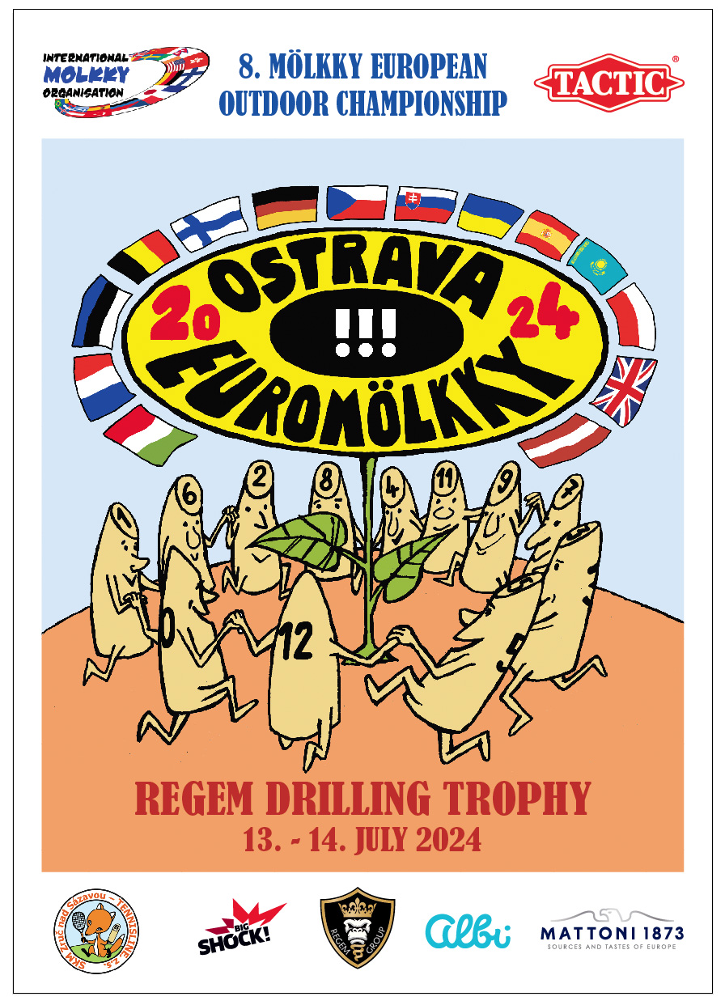

**8. Mölkky European Outdoor Championship**

**EUROMÖLKKY 2024**

**REGEM DRILLING TROPHY**

**Organizer:** Czech mölkky association + SKM Zruč nad Sázavou – Tennisline, z. s. Na Výsluní 752, 285 22 Zruč nad Sázavou

**Contact person:** Leoš Fiala, Dvouletky 710, 285 22 Zruč nad Sázavou leos.fiala@volny.cz, m. +420-777 922 395

**Organizingcommittee:** Leoš Fiala chairman [leos.fiala@volny.cz](mailto:leos.fiala@volny.cz) m +420 – 777 922 395

Ing. Pavel Kožuch Tournament Director m. +420-733 559 313 Ing. Radim Freisler Tournament Director Ass. m. +420-602 404 680

Stanislav Ozimý referee m. +420 – 724 576 127 Petr Hanyk referee assistent m. +420 – 724 154 553 Leoš Fiala referee assistent m +420 – 777 922 395 Olena Osovská, Vojtěch Plecháč results processing Adam Janečka gastroservis Peter „Chelsea“ Kalaba discjockey Mária Fialová, Pavla Loudová mölkky shop Michal Osovský, Vasyl Osovský, Pavel Mácha, Jan Zábrana technical operatives

**DateofChampionship:**  **11. – 14. 07. 2024**

**VenueofChampionship:** TJ Ostrava – sport area, www.tjostrava.cz Varenská 3098/40a, 702 00 **Ostrava**, Czech Republic

**Numberofparticipants:** **72**teams

**Registration:** must be done during **01. 01. – 16. 06. 2024** at website [www.euromolkky.cz](http://www.euromolkky.cz)

**Startingfee:** **80** Euro for team – EUROMÖLKKY 2024 13.-14.07.24 **12** Euro forplayer – BEACH OPENING 11.07.24 **25** Euro for team –DOUBLES WARM UP 12.07.24

**Teams:**  each team consists of 3 – 4 players, captain of the team must be above the age of 18

**Fields:** **24** numbered fields, 6 x 12 m,red clay surface

**Mölkky:** games are always played with official Tactic

**Restaurant and sanity facilities:** in the sports area TJ Ostrava

**Accommodation:** Hotel Brioni, Hostel TJ Ostrava or www.booking.com

**Medical service:** non-stop first aid trained staff

**Alcohol:** alcoholic beverages are prohibited in the playing fields

**Smokin g:** smoking is prohibited during the game, allowe only in designated areas

**Referees:** official referees at each field are nominated by the organizer (for semi-finals, finals and bronze medal match)

**Prizes:**  medals, cups and material prizes for teams in 1.– 3. Place of European Championship medals for teams in 4.– 10. Place of European Championship medals and plaques for teams in 1. – 4. Place of Last ChanceTournament

medals, cups for teams in 1.– 3. Place of Europe Cup

medals and plaques for players in 1. – 12. Place of Beach Opening

medals and plaques for teams in 1. – 6. Place of Doubles Warm Up

**Rules:** official I. M. O. mölkky rules are followed, throw is delimited by Mölkkaari

**Playing system: EUROMÖLKKY 1stDay 8** Groups, each **9** teams (best **6** to **PLAY OFF**)

**2ndDay** a) **PLAY OFF** (**48** teams) b) Battle for 33th place c) Battle for 17th place d) Battle for 9th place, placement matches 9.-16. e) Battle for 5th place, placement matches 5.-8.

**LAST CHANCE TOURNAMENT 24** teams, k. o . systém, placement matches

**BEACH OPENING** Finnish groups (3 players), 4 rounds

**DOUBLES WARM UP** 60 teams, swiss systém, 6 rounds

**EUROPE CUP** 16 teams - play off and placement matches 1.-16.

**Time schedule:**

**01. 01. – 16. 06. 2024** e-mail registration at www.euromolkky.cz

**Tuesday 18. 06. 2024** 18:00 draw

**Wednesday 19. 06.2024** 12:00 release of draw results and timeschedule at website www.euromolkky.cz

**Thursday 11. 07. 2024** **17:00 – 21:00 BEACH OPENING tournament 48 players**

**Friday 12. 07. 2024** 12:30 BEACH OPENING – medals ceremony (best 12 players)

**13:30 – 18:30 DOUBLES WARM UPtournament 60 teams**

19:00 DOUBLES WARM UP – medals ceremony (best 6 teams)

16:00 – 21:00 presentation, issuing of starting numbers, training, friendly matches

**Saturday 13. 07. 2024** 08:30 – 9:30 presentation, issuing of starting numbers

09:45 opening ceremony

**10:00 – 16:00 matches in groups**

**16:30 EUROPE CUP – nation teams**

19:00 EUROPECUP – medals ceremony (best3 teams)

**Sunday 14. 07. 2024** 10:00 1st and 2ndround of Last Chance Tournament **10:00 Play off – 1st Round** (best of 3 sets) **10:45 Play off – 2nd Round** (best of 3 sets) **11:30 Play off – 3rd Round** (best of 5 sets) **13:00 Play off – quarterfinal** (best of 5 sets) **14:30 Play off – semifinal** (best of 5 sets) 15:15 Last Chance Tournament final and bronze medal match 15:15 European championship – bronze medal match **16:00 European championship final**  17:00 medals closing ceremony